**Covariance:**

In mathematics and statistics, covariance is a measure of the relationship between two random variables. The metric evaluates how much – to what extent – the variables change together. In other words, it is essentially a measure of the variance between two variables. However, the metric does not assess the dependency between variables.

**Formula for Covariance**

The covariance formula is similar to the formula for correlation and deals with the calculation of data points from the average value in a dataset. For example, the covariance between two random variables X and Y can be calculated using the following formula (for population):

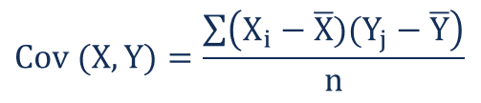

For a sample covariance, the formula is slightly adjusted:

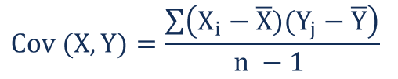

**Example**

First, Mr. Shah obtains the figures for both ABC Corp. stock and the S&P 500. The prices obtained are summarized in the table below:

